Field Trip to the Ninepin Islands
Leader: Prof LS Chan
Date: 8 July 2017 (Sat)
Meeting Point: Public Pier, TST
Time: 8:30 am

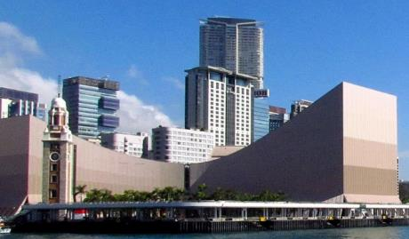
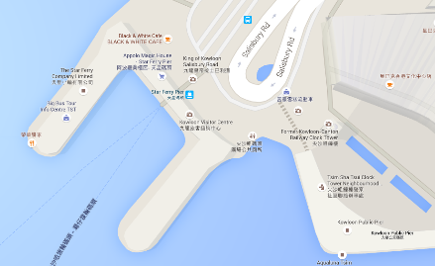

Itinerary:
We will ride from TST Public Pier through eastern waters and Tathong Channel to the Ninepin Islands. The ride is about an hour each way. We’ll connect onshore in small boats. A first landing will be made on the Northern Ninepin to view some spectacular rock columns, toppled rocks, and amazing onion-like weathered rocks. We’ll then cruise around the islands for the Southern Ninepins, where we may walk up to a sea arch or goof around by a beach. Time and weather permit, we may swing by East Ninepin or the Waglan Islands on the way back. The group will return to TST Pier by about 5 pm.

Preparation:
Prepare for both rain and shine. Bring own lunch and drinks. We’ll be walking for a total of about 1.5 hour, in parts on rocky outcrops. Wear comfortable boots or walkers. Bring own personal items and medication if necessary. The sea should not be too rough. But if you get motion sickness easily, you may want to take motion sickness medicines. Remember you may have to do so two hours prior to the boat ride. Camera is a must.

Weather adversaries: The trip will be cancelled in case of red rainstorm or at Typhoon signal #3 at 7 am of the day. Please keep an eye on last-minute notification.

Bring own lunch and drinks. Please be punctual.
Contact information: Mr. Eric Lai (9186 2456) / Mr. Chris Li (9803 9691)
