Caritas Bazaar 2014 Organizing Committee

ORDERING FORM FOR SOUVENIRS

T-shirts | (Front)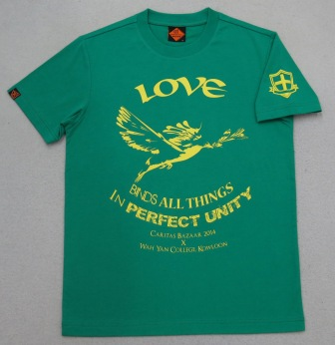 | (Back)  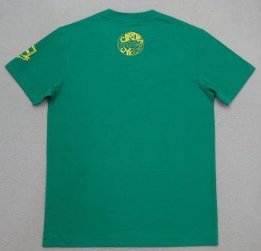
Towel | 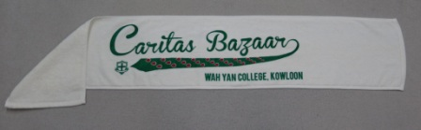
Tote Bag | 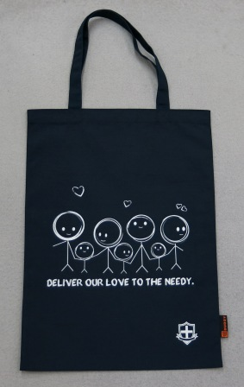
ORDER SLIP

NAME (ENGLISH): __________________________ NAME (CHINESE): _____________________

EMAIL ADDRESS: _____________________________ MOBILE NO. : _______________________

GRADUATION YEAR (FORM 5 / SECONDARY 6): ________________________________________

 |  | QUANTITY | SUB-TOTAL (HK$)
T-SHIRT (HK$200) | SIZE: XL
 | SIZE: L
 | SIZE: M
 | SIZE: S
 | SIZE: XS
TOWEL (HK$150)
TOTE BAG (HK$170)
SOUVENIRS PACKAGE  1 T-SHIRT + 1 TOWEL + 1 TOTE BAG (HK$500) |  | (T-SHIRT SIZE: )

TOTAL (HK$): ______________

Please make all cheques in respect of the payment payable to “Father Kelly Educational Fund Ltd.” and return the form with the crossed cheque by post to Caritas Bazaar 2014 at Wah Yan College Kowloon, 56
Waterloo Road, Kowloon.

Please also state “For Caritas Bazaar 2014” and your name at the back of the cheque.

Should you have any enquiries, please feel free to contact the chairman of Caritas Bazaar Organizing Committee 5Y Jonathan Lau at 6803-9355 or wykbazaar2014@gmail.com for more details.

