**Wah Yan College Kowloon   
Past Students’ Association Ltd.**56 Waterloo Road, Kowloon

**ORDERING FORM FOR WYKPSA FOOTBALL JERSEY**

**(Deadline: 23 May 2014)**

|  |  |  |
| --- | --- | --- |
| **Standard (Front) –** For both option 1 and 2 | **Option 1 – Blank (Back)**  HK$360@  (Green in colour) | **Option 2 -- Waterloo 56 (Back)** HK$380@  (Green with 56 & WATERLOO in white) |
| IMG-20140410-WA0006.jpg |  |  |

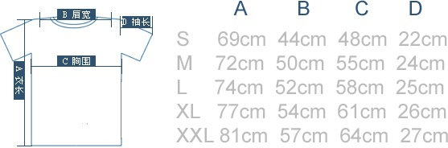

**Wah Yan College Kowloon   
Past Students’ Association Ltd.**56 Waterloo Road, Kowloon

**ORDER SLIP**

Name (English): _____________________________________ Name (Chinese): ___________________

Email address: _______________________________________ Phone number: ____________________

Year of graduation from WYK (Form 5 (if under HKCEE academic structure) or Secondary 6 (if under new senior secondary curriculum)) / highest form attended (please specify): ____________________

|  |  |  |  |  |  |  |
| --- | --- | --- | --- | --- | --- | --- |
|  |  |  |  |  |  | Subtotal (HK$) |
| **Option 1** | Size: | S | Quantity: | _____ | x HK$360 = | _________ |
| **Blank (Back)** |  | M |  | _____ | x HK$360 = | _________ |
| @HKD360 |  | L |  | _____ | x HK$360 = | _________ |
|  |  | XL |  | _____ | x HK$360 = | _________ |
|  |  | XXL |  | _____ | x HK$360 = | _________ |
|  |  |  |  |  |  |  |
| **Option 2** | Size: | S | Quantity: | _____ | x HK$380 = | _________ |
| **Waterloo 56 (Back)** |  | M |  | _____ | x HK$380 = | _________ |
| @HKD380 |  | L |  | _____ | x HK$380 = | _________ |
|  |  | XL |  | _____ | x HK$380 = | _________ |
|  |  | XXL |  | _____ | x HK$360 = | _________ |
|  |  |  |  |  |  |  |
|  |  |  |  |  | **TOTAL (HK$)** | **_________** |

Please bank in the sum to the WYKPSA’s bank account below directly and send the order form with the bank-in slip/bank transfer slip to [wykpsafig@gmail.com](mailto:WYKPSAFIG@gmail.com). Collection of jersey will be arranged during Exco Meeting of the WYKPSA. Exact date to be notified when stock is ready.

**Bank details:**

Bank: HSBC

A/C No.: 808-024525-001

A/C Name: Wah Yan College Kowloon Past Students’ Association Limited

**Deadline: 23 May 2014**

*Attention: Football interest group (FIG) members would enjoy TWO free gathering sessions on ordering a jersey. Interested party please send an email for registration as a member of the FIG at* [*wykpsafig@gmail.com*](mailto:WYKPSAFIG@gmail.com)

*WYKPSA keeps the personal data for the purposes of ordering of WYKPSA Football Jersey only and the usage and keeping of such data is in accordance with the provisions of the Companies Ordinance and Personal Data (Privacy) Ordinance.*